**Review Application Build Deliverables**

**Module Description**

For this simulation module you will be checking in and ensuring that all the deliverables built so far are correct.

**Time Warp Presentation**

Click the link to launch the [Module 37 Time Warp Presentation](https://accenture.desire2learn.com/content/enforced/9406-Pending/W4_Participant_Materials/Module_37/ADF_2_0_Java_M37_TimeWarp_PD.pptx?_&d2lSessionVal=YnoL4daZGC8ne2RyGf0cWMrk8).

**Scenario**

Once Unit Testing and Assembly Readiness testing is complete, you and the rest of your team will check the created classes and components, the code, unit test deliverables and the other build documentation for completeness, consistency and correctness.

Once the review is complete and confirmed (by the Team Lead during the Team Lead review), key modules are reviewed by the stakeholders (e.g., sponsors, client application users, etc.) to sign off successful completion of the build phase.

As the team completes various work products and places them into the appropriate repositories, the Team Lead will review the work products as recommended in the Application Build Checklist. The Team Lead also performs the following checks:

* Review a number of Peer Review Feedback Forms and confirm their completion and sign-off.
* Review the most critical (high risk) code and make sure that the JUnit and Stub Code are effectively testing all of the appropriate conditions (you could do this with the developer who wrote the code).
* Discuss any issues with the team and follow through on the completion of the corrections.

**ADM Activity Context Diagram**

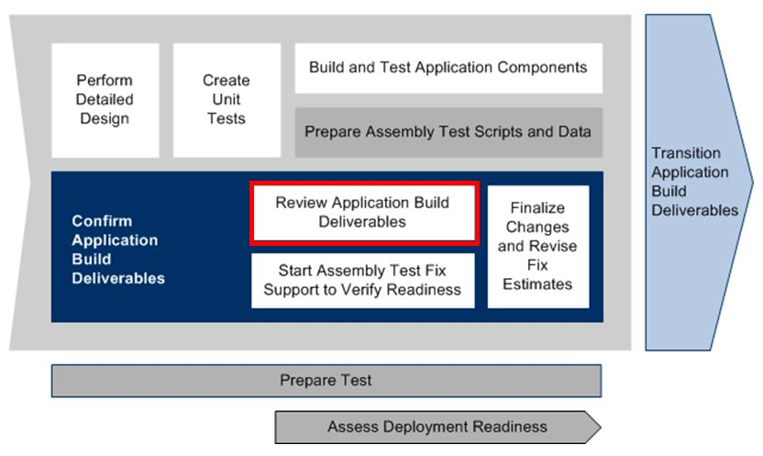

**Roles**

|  |  |  |  |
| --- | --- | --- | --- |
| **Role** | **ADM Task** | **ADM Responsibility** | **Description** |
| Developer | 4191 - Review Application Build Deliverables | Primary Performer | Creates the Build Completion Report and the Release Notes.  Confirms that all the work products are in the appropriate code or document repository. |
| Team Lead | Team Lead Review | Primary Performer | Reviews the Application Build Deliverables using the Application Build Checklist.  Reviews the Requirements and Traceability Document to confirm completion of activities. |

**Participant Instructions**

1. Review the Application Build Checklist (see below) and make sure the current project build deliverables meet the criteria listed on this checklist.

**During the Team Lead Review, the Team Lead will:**

1. Review the [Exit/Entry Criteria](https://accenture.desire2learn.com/content/enforced/9406-Pending/NCCC_Project_Work_Products/1_PM/Release_1/ExtEntCrit_FERS_R1_REF.xlsx?_&d2lSessionVal=YnoL4daZGC8ne2RyGf0cWMrk8) to confirm all the items listed have been satisfied.
2. Confirm that deliverables have been completed.
3. Confirm that application code (except stub code) and JUnit code is checked into the code repository, and meets the [Application Development Standards](https://accenture.desire2learn.com/content/enforced/9406-Pending/NCCC_Project_Work_Products/4_Tech_Arch/Release_1/AppDevStd_FERS_R1_REF.docx?_&d2lSessionVal=YnoL4daZGC8ne2RyGf0cWMrk8) (formatted, no debug or in-line code like assertions).
4. Review Peer Review Feedback Forms and sign off on them.
5. Review the most critical/high risk code and make sure the JUnit and stub code is effectively testing all the appropriate conditions (you could do this with the developer who wrote the code).
6. Document issues (as needed) in the Peer Review Feedback Form.

**Application Build Checklist**

Confirm the following has been done to ensure the project is ready to move to the next stage:

**Unit Test**

* Successfully execute all unit test cycles and scripts.
* Document, fix, and retest all defects.
* Ensure full code (statement and branch) coverage.
* Clearly document any unresolved defects and issues.

**Assembly Test**

* Ensure assembly tests have been created for each of the scenarios identified during design.
* Ensure that the application build functions properly when executing Assembly Readiness test scripts.

**Application Code**

* Perform a code review on all code modules.
* Ensure that code modules can be traced back to the corresponding designs and analysis items.
* Resolve all issues found during the testing of the application build.

**Hints and Tips**

* **Team Lead only**: Check Deliverables as they are completed by team members. Do not wait until the end to review everything.